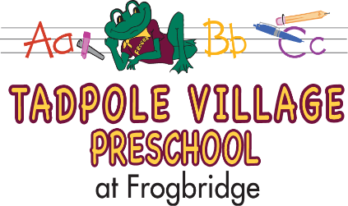

PARENT
RECEIPT OF INFORMATION:

Please check each box and sign below.

□ Information to Parents Document
□ Policy on the Release of Children
□ Positive Guidance and Discipline Policy
□ Policy on Methods of Parental Notification
□ Policy on Communicable Disease Management
□ Expulsion Policy
□ Policy on the Use of Technology and Social Media

The Parent/Guardians who signs this receipt of information represents that he/she has the authority to do so and verifies that he/she has read and received a copy of the information/policies listed above and understands and agrees to abide by all the terms and conditions of these agreements/policies.

____________________________________________________
Child(ren)’s Name

____________________________________________________
Parent/Guardian’s Name

_________________________ ____________
Signature Date
7 Yellow Meeting House Road
Millstone Twp., NJ 08514
609-208-2114
7 Yellow Meeting House Road
Millstone Twp., NJ 08514
609-208-2114

